Class 2

Activity 2: Making Something

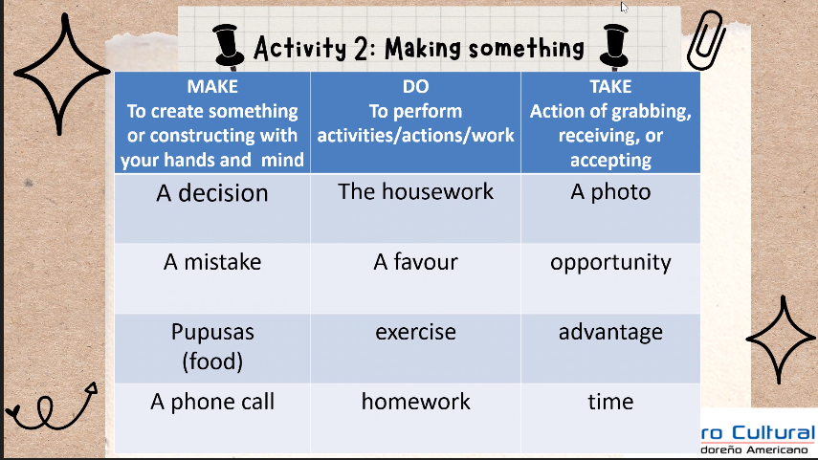

**Activity 3: Have you?**

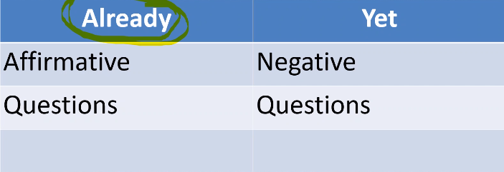

Already using only affrimatice and question

Yet using Negative and Question

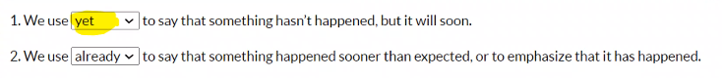

**Examples:**

I haven’t done my homework yet → yet: after the verb or at the end

I have already done my homework → Already: Between has/have and the verb

**Exercise**

i haven't pay a yet

i have already pay

**GRAMMAR: Present Perfect + yet/already**

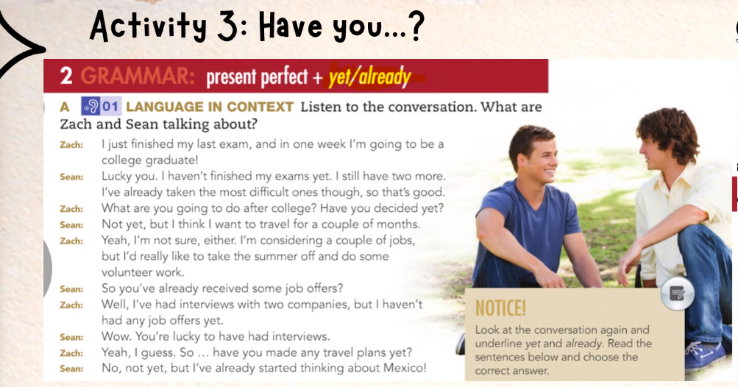

**=======================================================================**

**he hasn’t send a email a yet**

**3 goals already**

1. i have already completed my subjects of the pensum

2. I have already visited Rio Dulce and the castle of the San Felipe

3. I have already gotten my grade senior in programming

**3 goals yet**

1.i haven't visit mexico yet

2.i haven't win competence of the programming yet

3.i haven't taken a photo with Fernanfloo yet

**=======================================================================**